**Install TensorFlow on Windows 10 using Anaconda**

by IreneTwo

TensorFlow, an open source machine learning tool

I’ll guide through steps to install it on Windows 10.

Step 1: Open Anaconda Prompt

Step 2: type ‘pip install tensorflow’

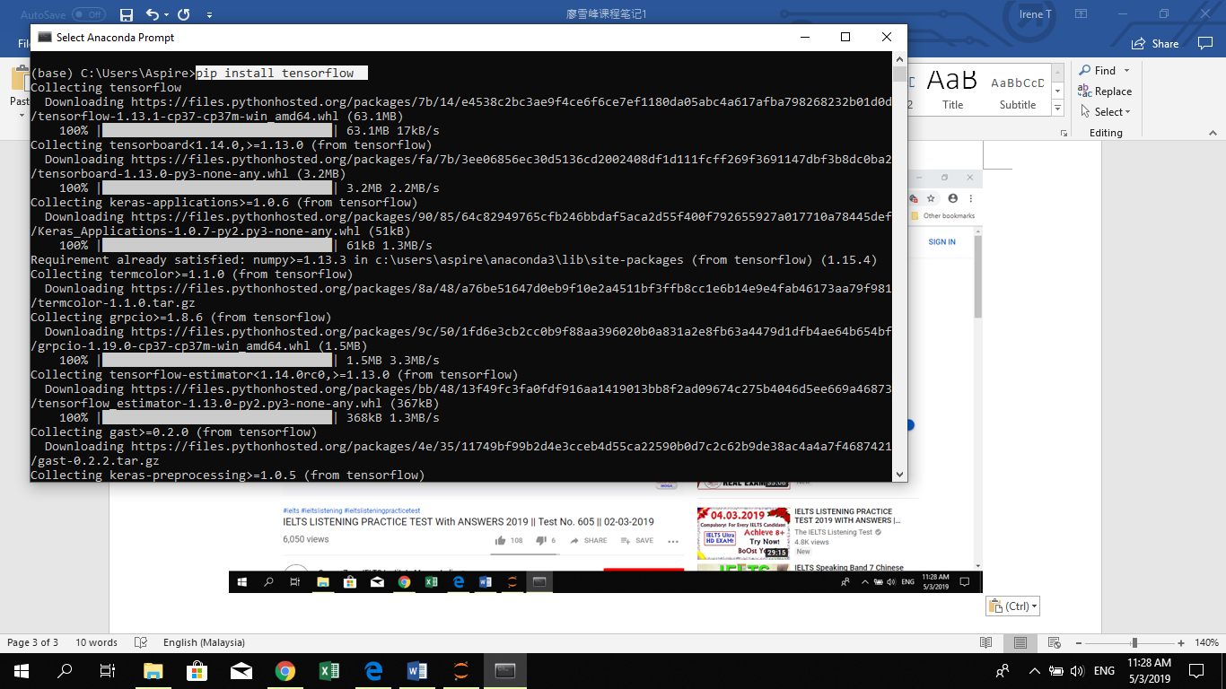

The anaconda prompt will start running and installing it.

Once done, you’ll see this in your anaconda prompt:

